EXPERIMENT 1

Develop a java program to add two matrices.

package add;

import java.util.Scanner;

public class Add{

public static void main(String[] args){

int m,n;

Scanner scan=new Scanner(System.in);

System.out.print("enter the number of rows in matrix:")

m=scan.nextInt();

System.out.print("enter the number of columns in matrix:")

n=scan.nextInt();

int a[][]=new int[m][n];

int b[][]=new int[m][n];

int c[][]=new int[m][n];

System.out.println("enter all the elements of first matrix:");

for(int i=0;i<m;i++){

for(int j=0;j<n;j++){

a[i][j]=scan.nextInt();

}

}

System.out.println("");

System.out.println("enter all the elements of second matrix:");

for(int i=0;i<m;i++){

for(int j=0;j<n;j++){

b[i][j]=scan.nextInt();

}

}

for(int i=0;i<m;i++){

for(int j=0;j<n;j++){

c[i][j]=a[i][j]+b[i][j]();

}

}

System.out.println("matrix after addition:");

for(int i=0;i<m;i++){

for(int j=0;j<n;j++){

System.out.print(c[i][j]+" " );

}

System.out.println("");

}

}

OUTPUT:

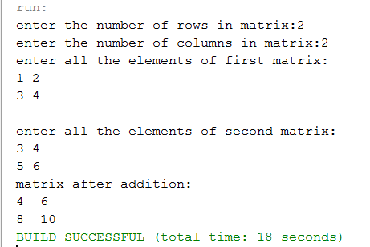

EXPERIMENT 2

Develop a Java program .develop a stack class to hold a maximum of 10 integers with suitable methods.Develop a Java main method to illustrate stack operations.

package stack1;

import java.util.\*;

public class Stack1{

int s[]=new int[10];

int top=-1;

int size=3;

void push(int i){

if(top==size-1)

System.out.println("Stack overflow.");

else{

s[++top]=i;

}

}

void pop(){

if(top==-1){

System.out.println("Stack underflow.");

}else{

System.out.println("popped element:"+s[top]);

top--;

}

}

void display(){

if(top==-1)

System.out.println("Stack is empty.\n");

else{

System.out.println("Stack elements are:\n");

for(int i=top;i>=0;i--)

System.out.println(s[i]);

}

}

public static void main(String args[])

{

Scanner scan=new Scanner(System.in);

Stack1 stk=new Stack1();

for(;;){

System.out.println("---Stack operations---");

System.out.println("1.push");

System.out.println("2.pop");

System.out.println("3.display");

System.out.println("4.exit");

System.out.println("enter your choice:");

int choice=scan.nextInt();

switch(choice)

{

case 1:

System.out.println("enter the element to push:");

stk.push(scan.nextInt());

break;

case 2:stk.pop();

break;

case 3:stk.display();

break;

case 4:System.exit(0);

default:System.out.println("invalid choice.\n");

break;

}

}

}

OUTPUT:

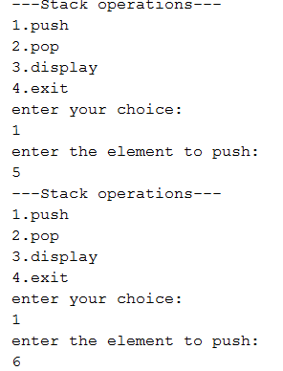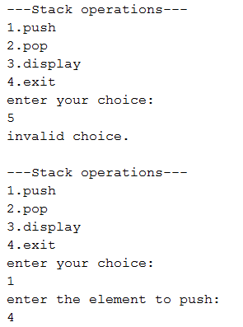

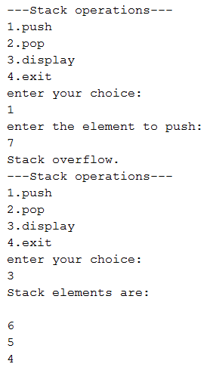

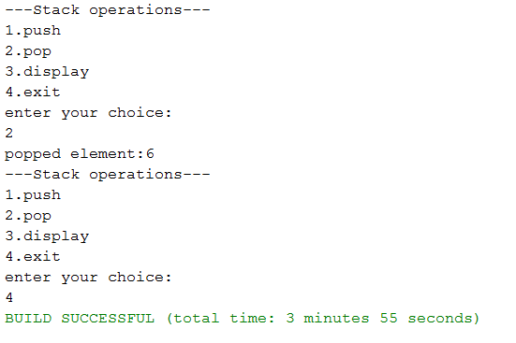

Experiment-3:

A class called employee,which models an id,name&salary is designed as shown in the following class diagram. The method raise salary(percent) increases the salary by the given percent . develop the emp class & suitable main method for demonstration .

package employee;

import java.util.Scanner;

public class Employee {

int id;

String name;

double salary;

public Employee(int id,String name,double salary)

{

this.name=name;

this.id=id;

this.salary=salary;

}

public void display()

{

System.out.println("Id:"+id);

System.out.println("Name:"+name);

System.out.println("Salary:"+salary);

}

public void raiseSalary(double percentage)

{

salary= salary+(salary\*percentage/100);

}

public static void main(String[] args)

{

int p;

Employee e1=new Employee(8,"Rakesh",2500);

e1.display();

Scanner scan=new Scanner(System.in);

System.out.println("\n enter the percentage to raise the salary");

p=scan.nextInt();

e1.raiseSalary(p);

System.out.println("\n after raising salary");

e1.display();

}

}

Output:

